PASS
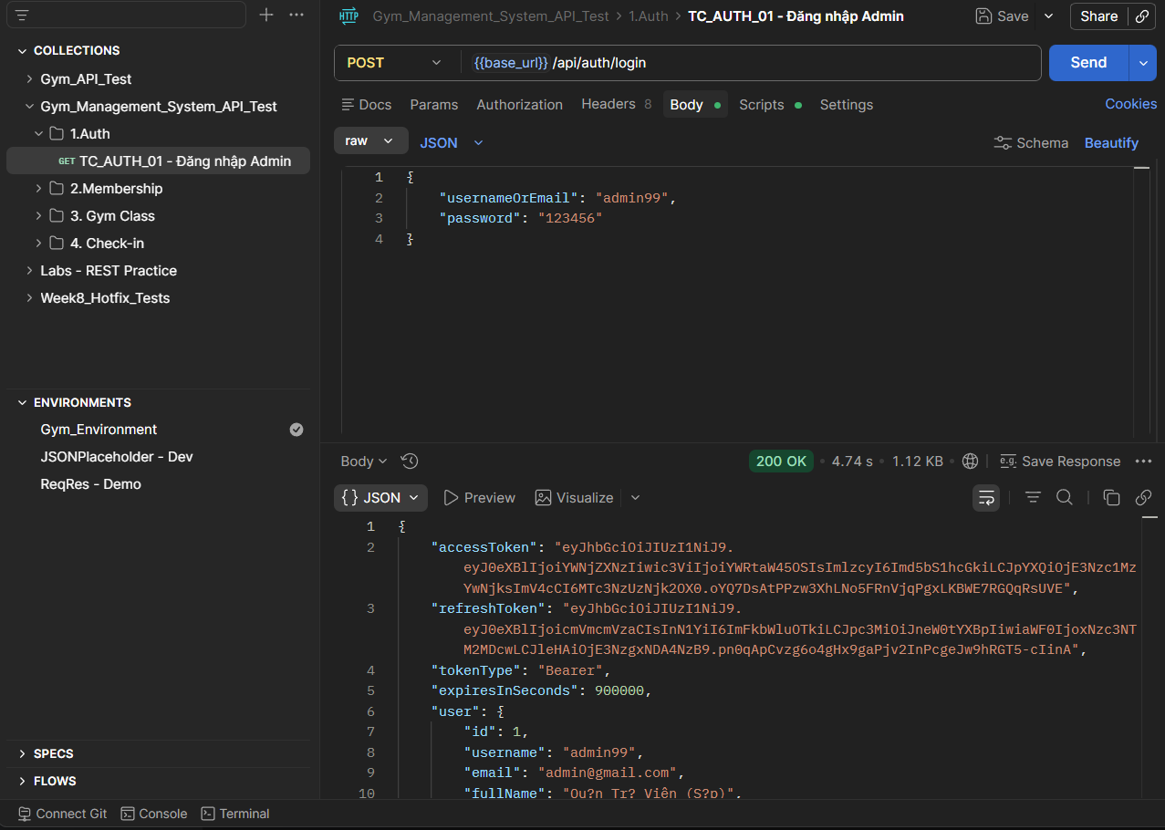
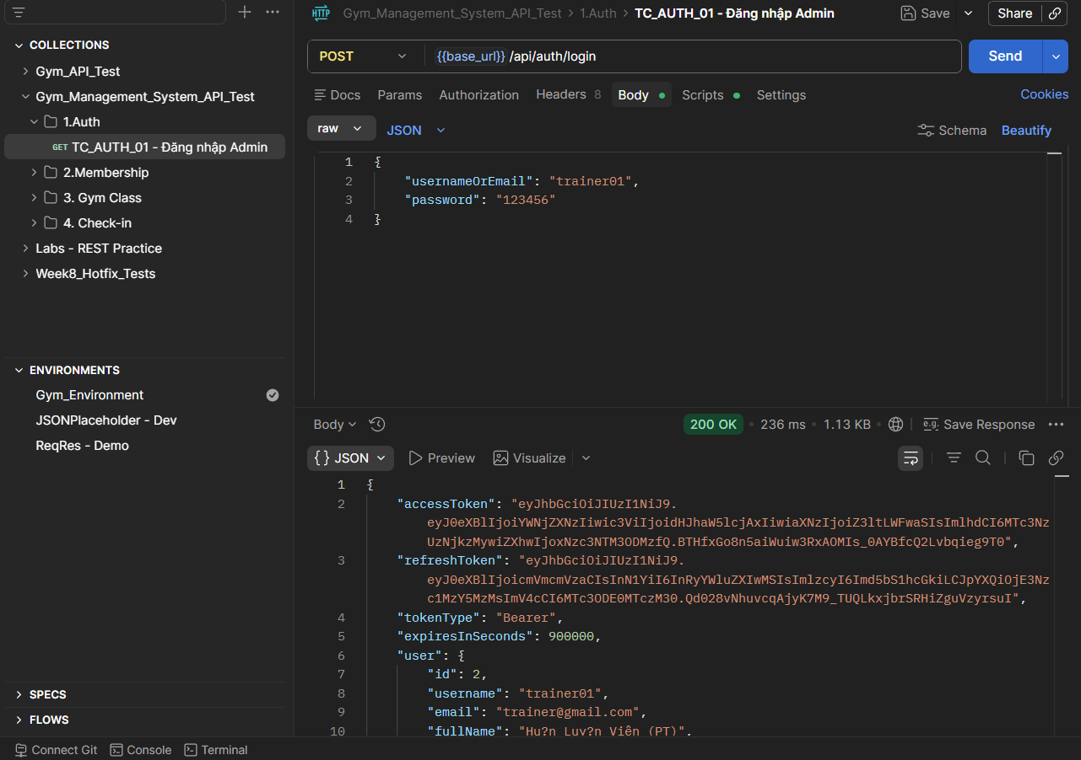

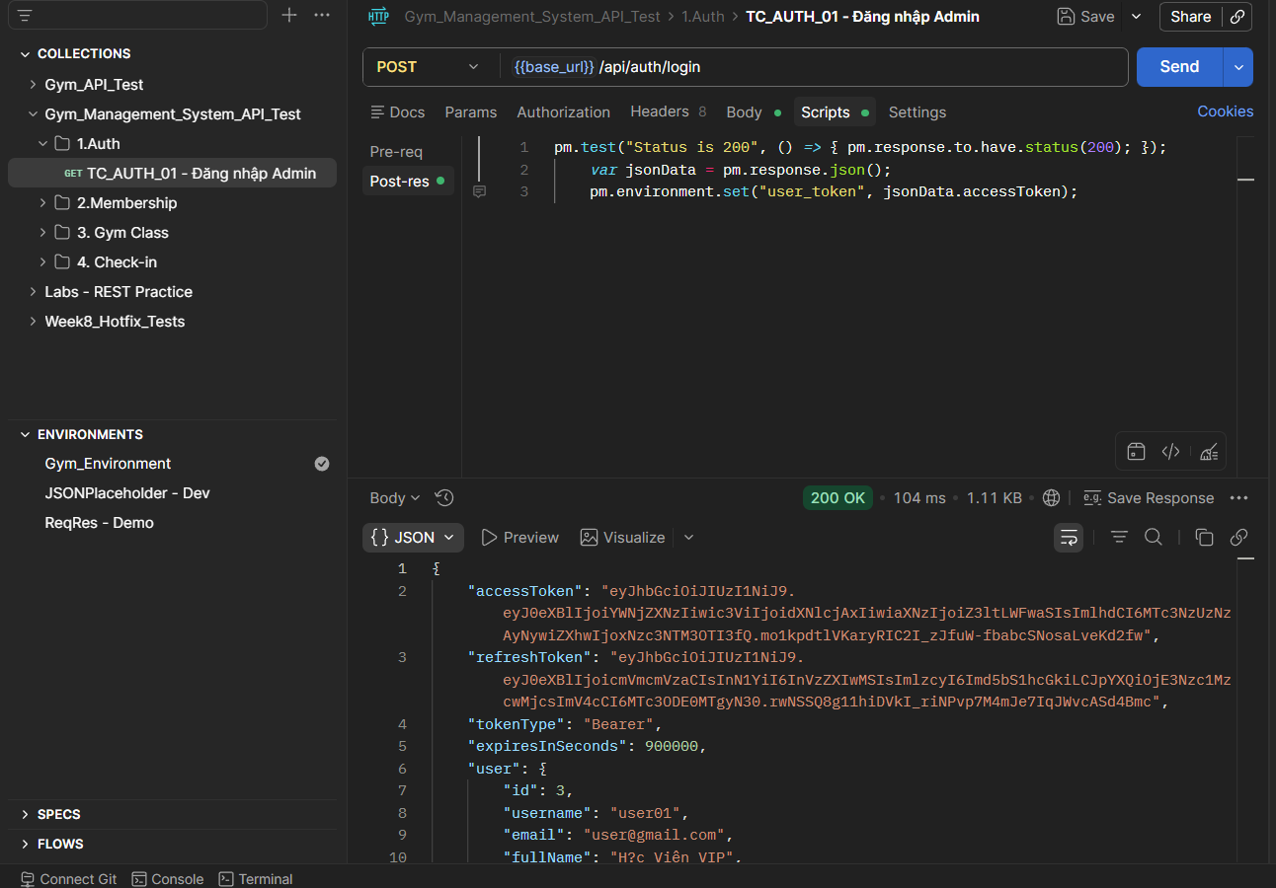

PASS
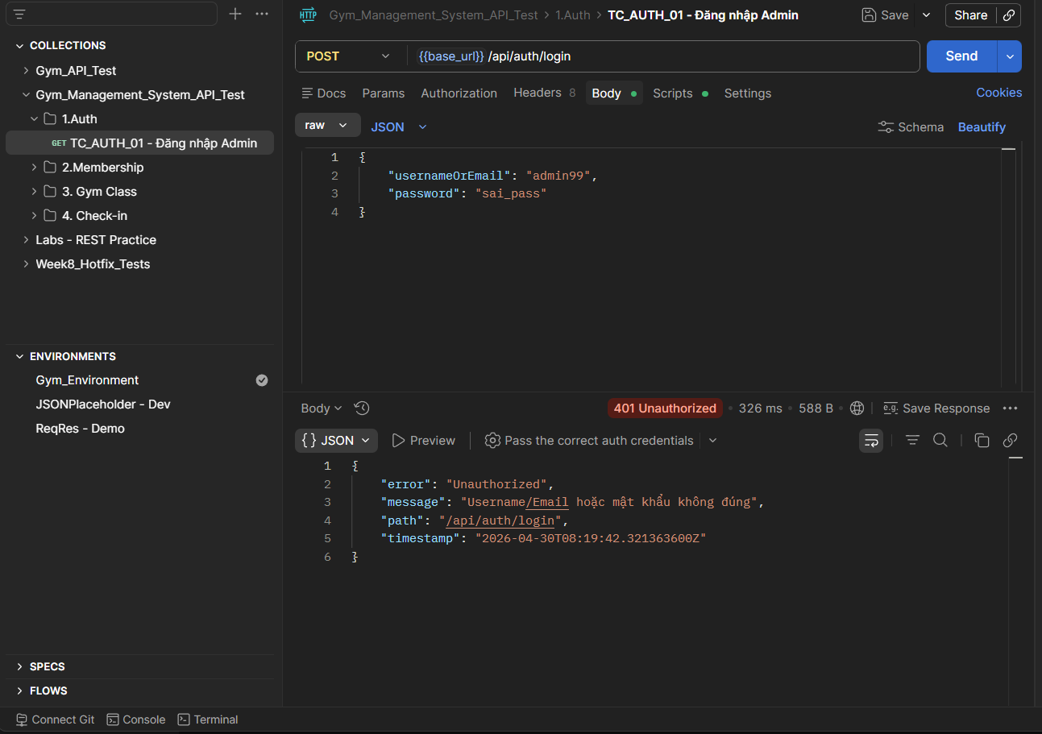
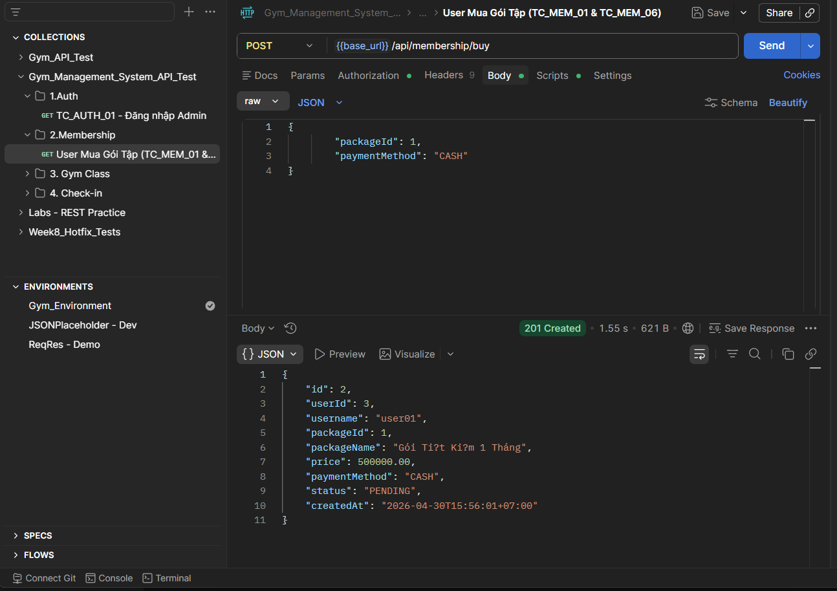

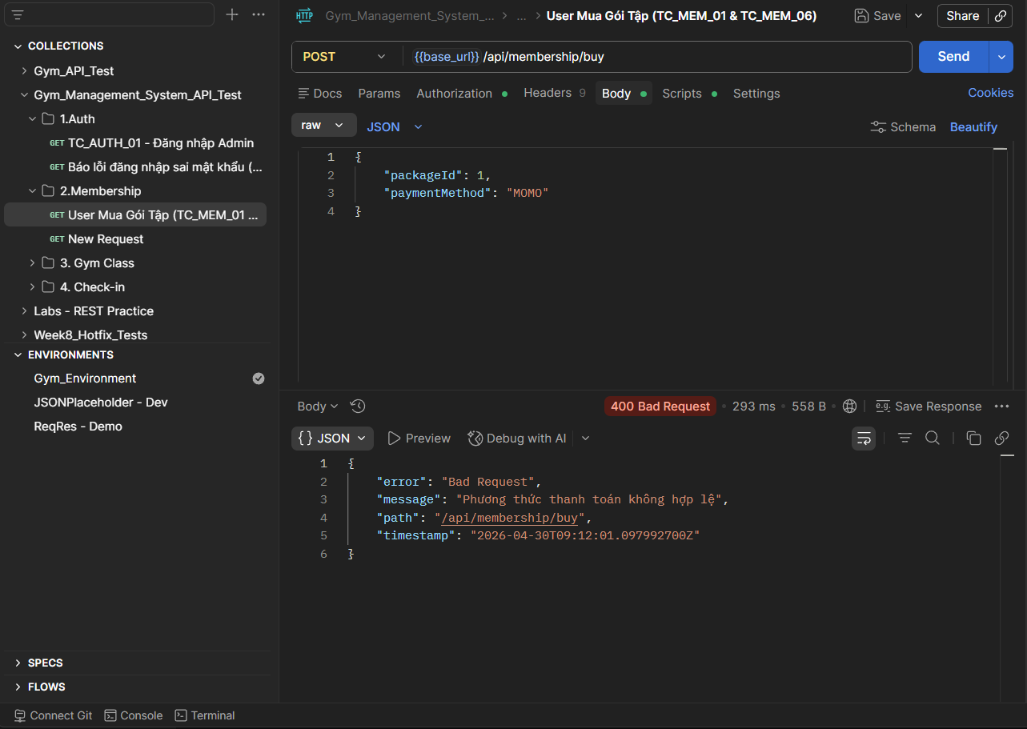

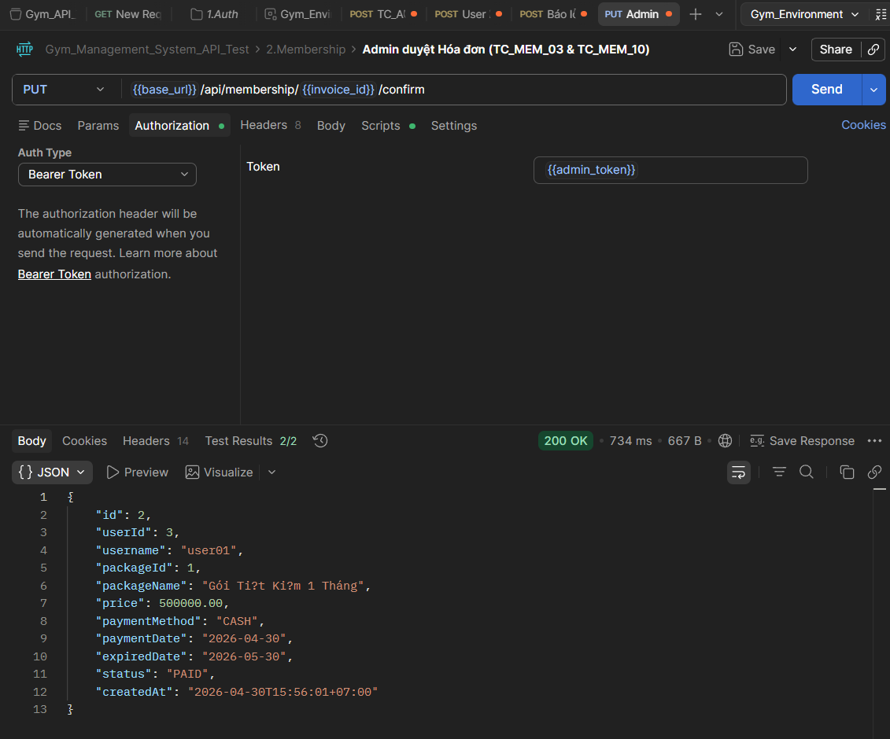

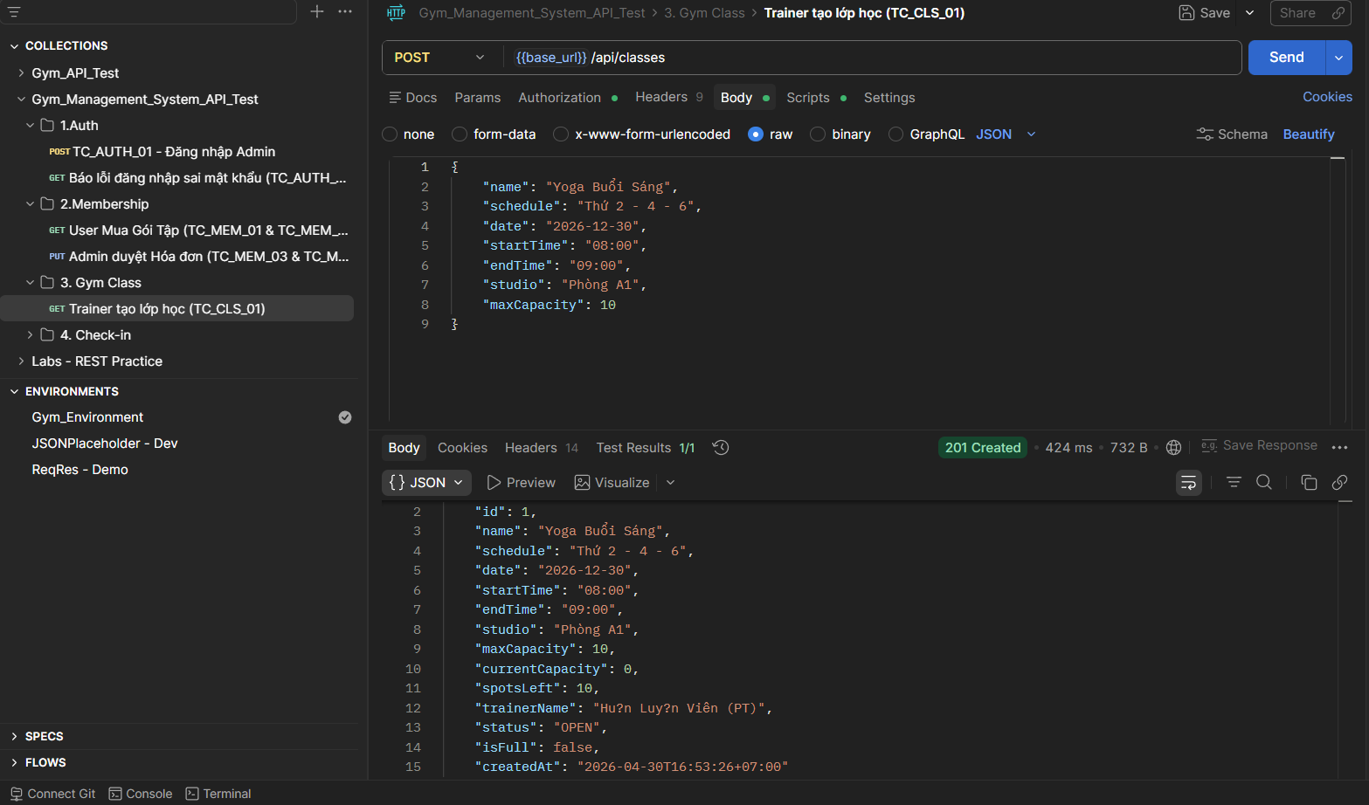
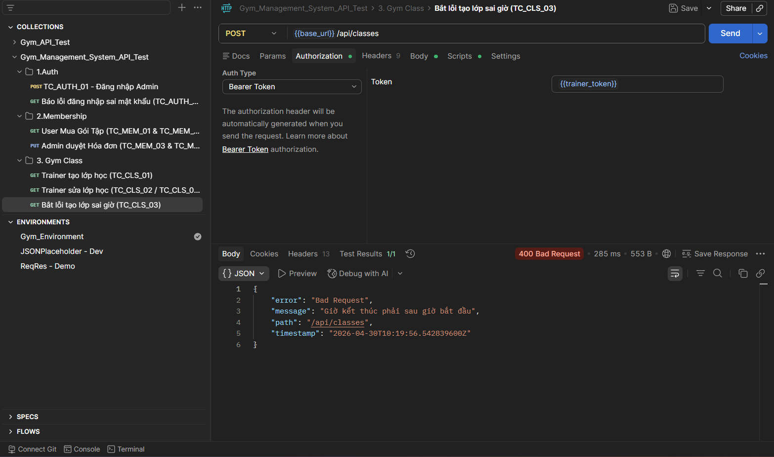

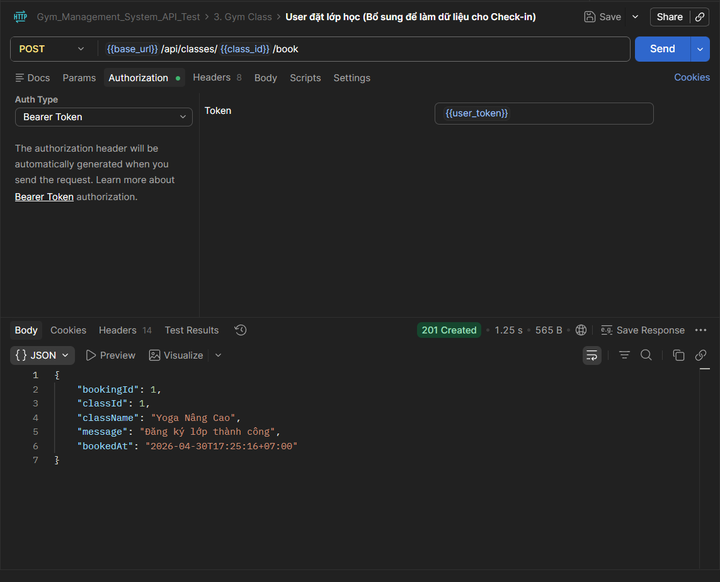
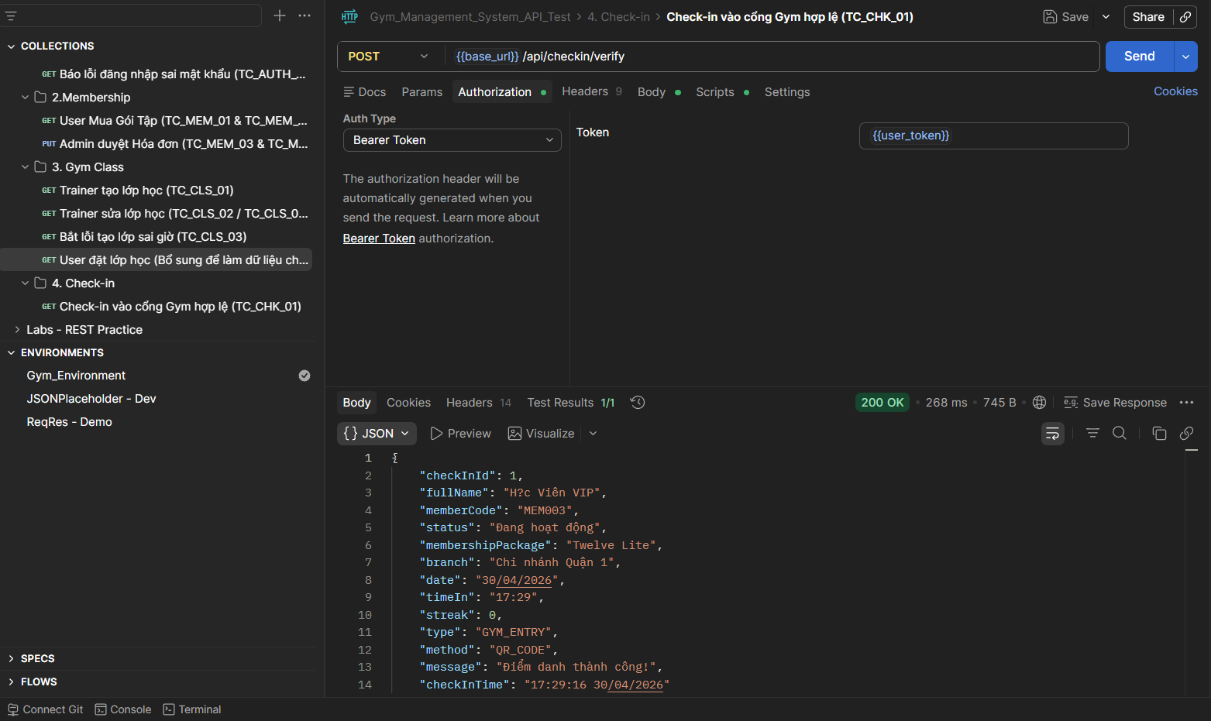

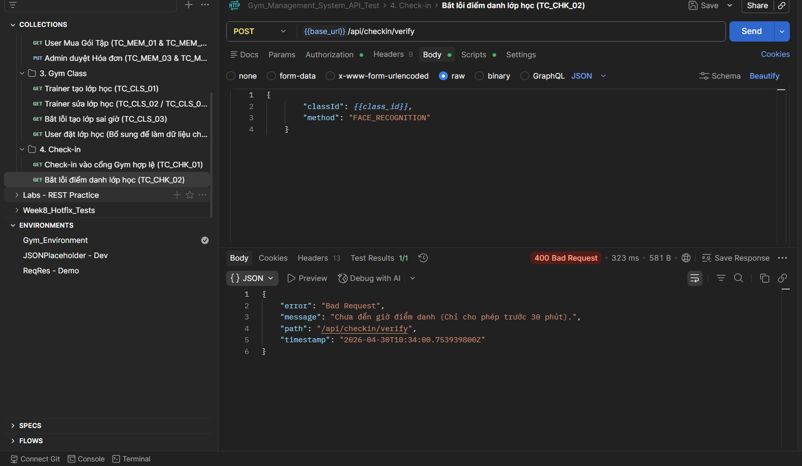

BUG
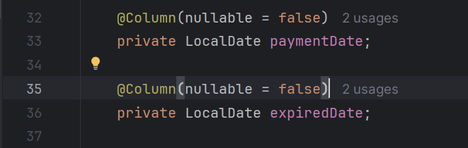

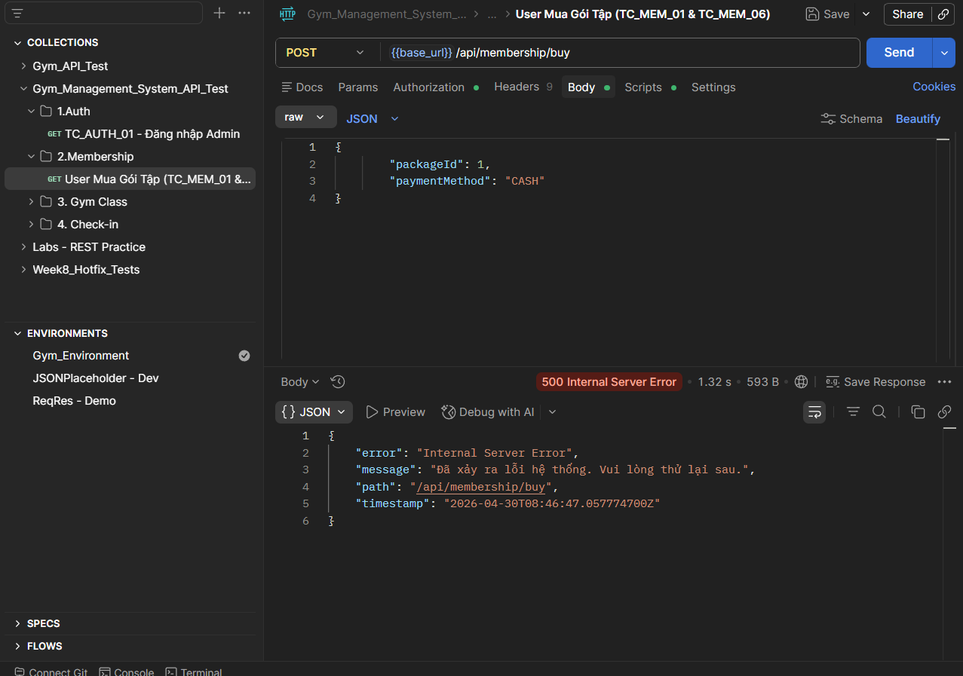
2026-04-30T15:46:47.061+07:00 WARN 18416 --- [nio-8081-exec-6] .m.m.a.ExceptionHandlerExceptionResolver : Resolved [org.springframework.dao.DataIntegrityViolationException: could not execute statement [Cannot insert the value NULL into column 'expired_date', table 'gym_management.dbo.invoices'; column does not allow nulls. INSERT fails.] [insert into invoices (created_at,expired_date,package_id,payment_date,payment_method,status,txn_ref,updated_at,user_id,version) values (?,?,?,?,?,?,?,?,?,?)]; SQL [insert into invoices (created_at,expired_date,package_id,payment_date,payment_method,status,txn_ref,updated_at,user_id,version) values (?,?,?,?,?,?,?,?,?,?)]; constraint [null]]

Bug: Sai Role phân quyền ở API GymClass"
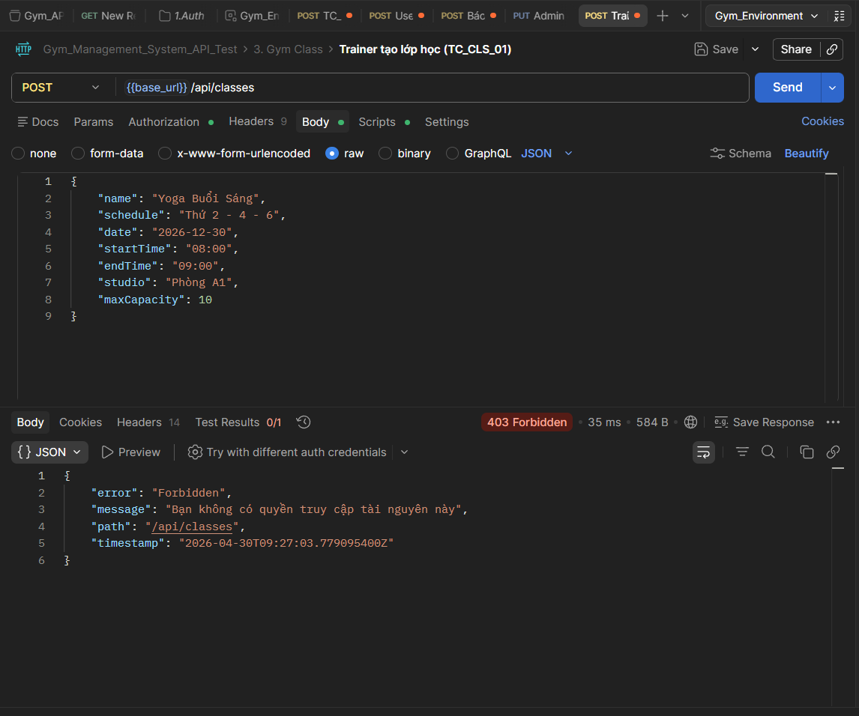

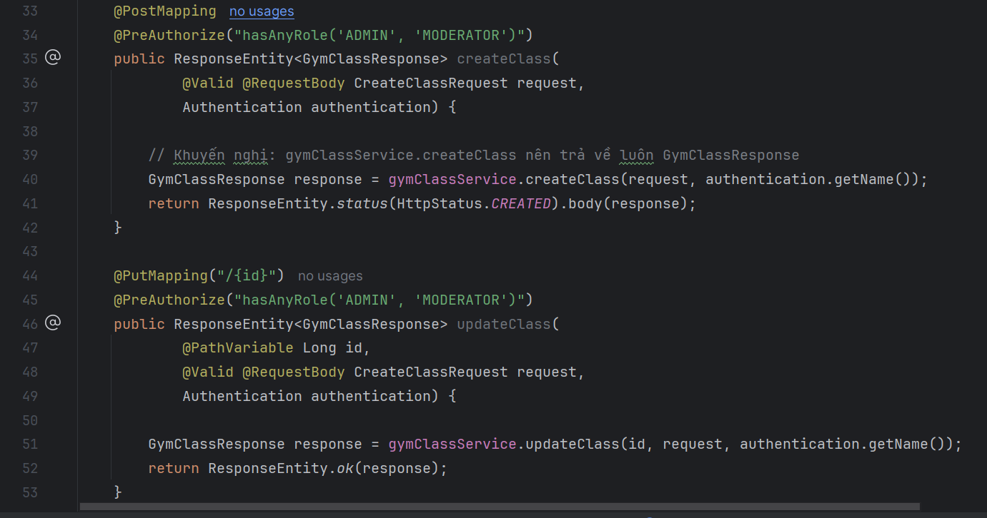
2026-04-30T16:27:03.781+07:00 WARN 4296 --- [nio-8081-exec-6] .m.m.a.ExceptionHandlerExceptionResolver : Resolved [org.springframework.security.authorization.AuthorizationDeniedException: Access Denied]

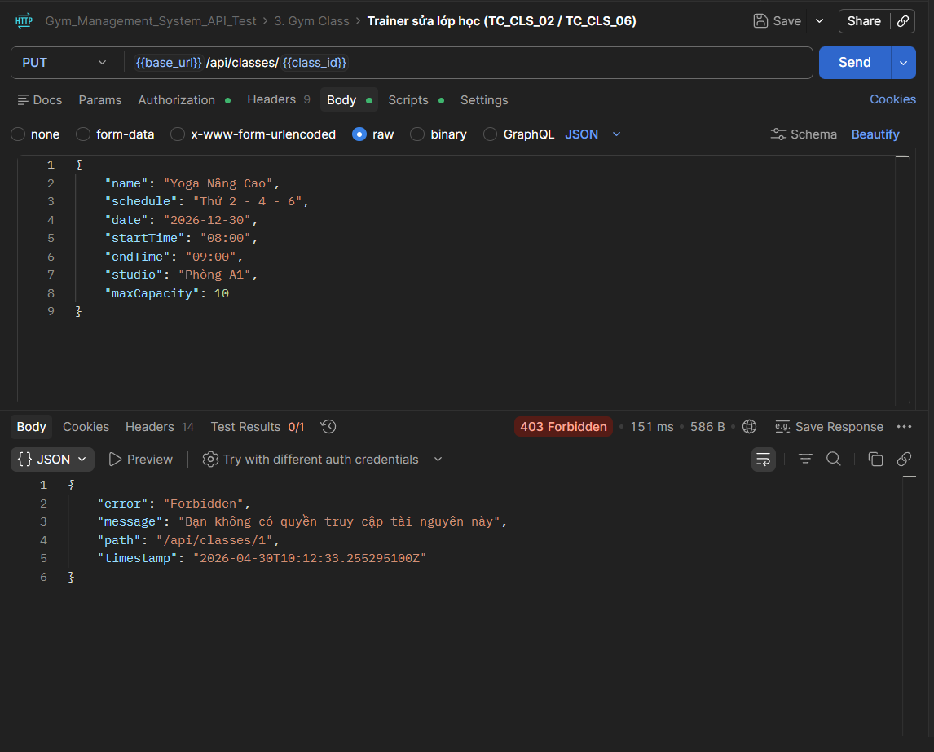
Cố tình sửa lớp bằng quyền Trainer (TC_CLS_02 - ĐỂ BẮT BUG DEV) (LỖI NHƯ TRÊN)

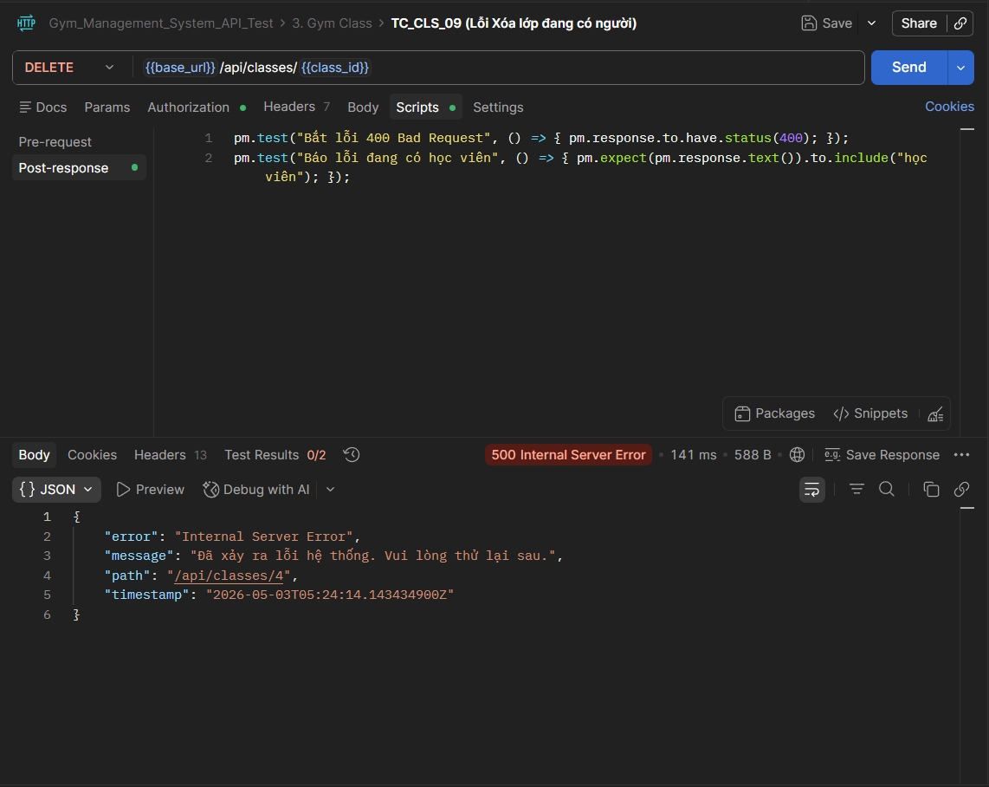
Bug: Xóa lớp đang có học viên bị văng lỗi 500 (Unhandled Exception / Foreign Key Constraint). Yêu cầu Dev bắt lỗi và trả về 400
2026-05-03T12:24:14.146+07:00 WARN 28628 --- [nio-8081-exec-2] .m.m.a.ExceptionHandlerExceptionResolver : Resolved [org.springframework.dao.DataIntegrityViolationException: could not execute statement [The DELETE statement conflicted with the REFERENCE constraint "FKmfman1yc6a3b0sjwfiu2304hk". The conflict occurred in database "gym_management", table "dbo.class_bookings", column 'gym_class_id'.] [delete from gym_classes where id=?]; SQL [delete from gym_classes where id=?]; constraint [null]]

